Practical No 4
Conditional Statement
Aim: Write a Python program to demonstrate conditional statements.
If Statement
- Check Whether a Number is Positive

Code 1:
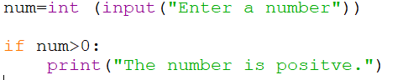

Output 1:
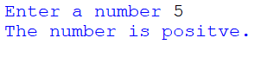

Output 2:
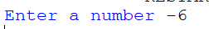

- Check Whether a Number is Even.

Code:
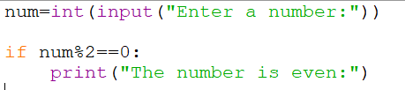

Output 1:
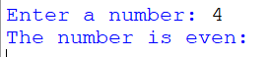

Output 2:

- Determine whether a person is eligible to vote.

Code:
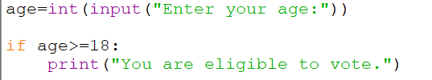

Output 1:
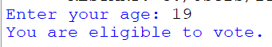

Output 2:
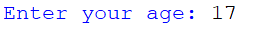

- Check Whether a Character is a Vowel

Code:
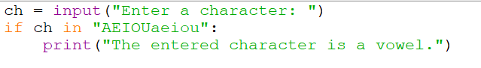

Output 1:
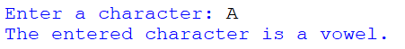

Output 2:
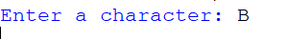

If — else Statement
- Check Whether a Number is Positive or Negative
Code:
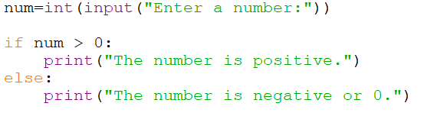

Output:
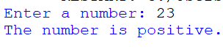
Output 2:
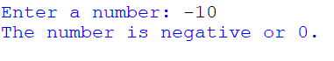

- Program to find whether the given number is even or odd.
Code:
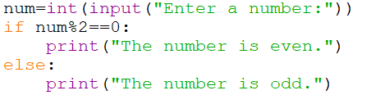

Output 1:
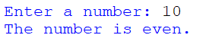

Output 2:
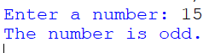

- Determine whether a person is eligible to vote or not. If not eligible, display how many years are left to be eligible.
Code:
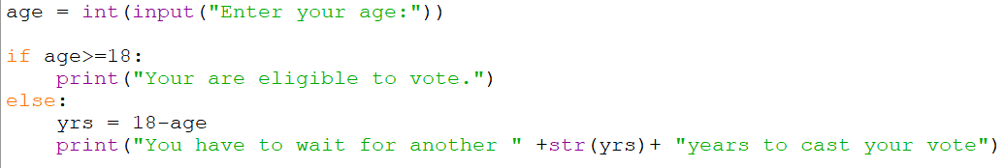

Output 1:
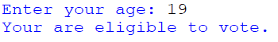

Output 2:

- Check Whether a Character is a Vowel or Consonant

Code:
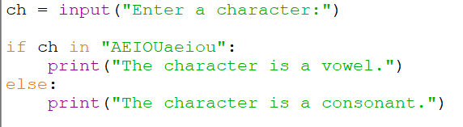

Output 1:
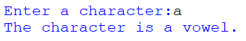

Output 2:
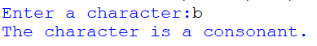

- Program to find larger of two numbers.
Code:
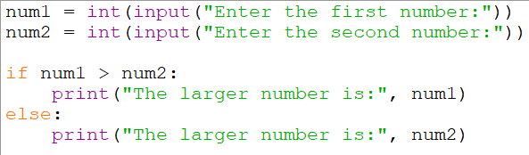

Output:
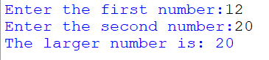

- Program to find whether a given year is a leap year or not.
Code:
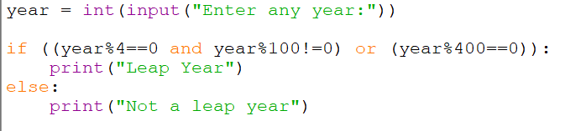

Output 1:
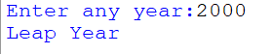

Output 2:
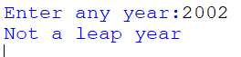

If — elif — else statement
- Check Whether a Number is Positive, Negative, or Zero.
Code:
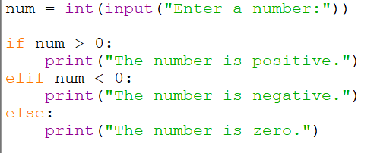

Output 1:
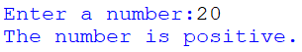

Output 2:
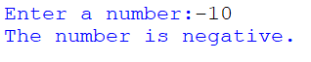

Output 3:
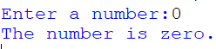

- Find the Largest of Two Numbers (Including Equal Case)
Code:
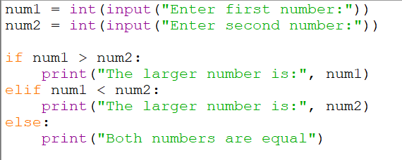

Output 1:
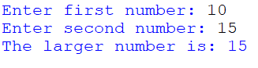

Output 2:
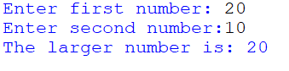

Output 3:
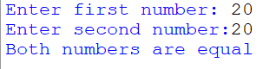

- Find the Largest of Three Numbers
Code:
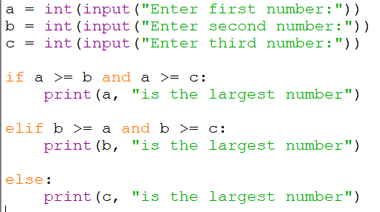

Output:
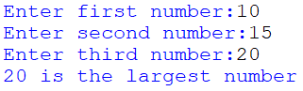

- Check Whether a Character is a Vowel or Consonant
Code:
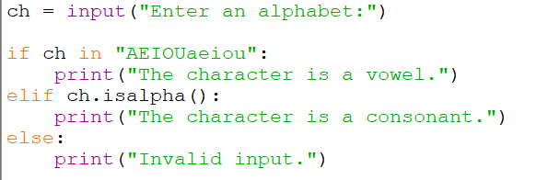

Output 1:
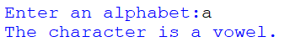

Output 2:
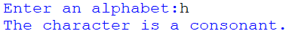

Output 3:
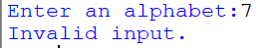

- Display Grade Based on Marks
Code:
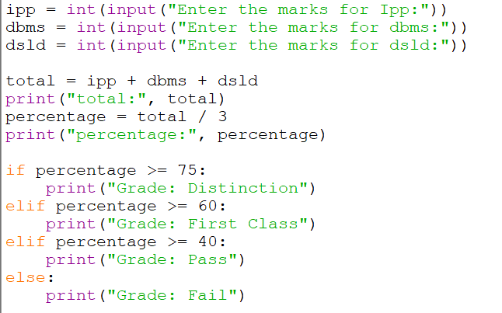

Output:
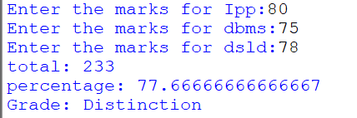

- Program that prompts the user to enter a number between 1-7 and then displays the corresponding day the week.

Code:
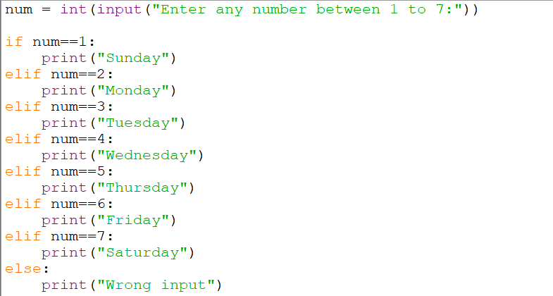

Output 1:

Output 2:


